The Prehistory of Probability

A Seminar/Discussion led by John N. Zorich, Jr.
for the Statistics Group of the Santa Clara Valley Chapter of ASQ
November 8, 2000

Let us take a journey thru time, from the conception of philosophical probability in ancient cultures, through the Medieval development of algebra, to the birth of mathematical probability in late-Renaissance Europe.

Seminar Outline:

Introduction

Philosophical Probability thru the End of the Renaissance

Mathematics and Statistics thru the end of the Renaissance

The Birth Of Mathematical Probability & Statistical Science

5. Why Was/Is It So Difficult to Discover/Learn/Understand Statistics and Probability?

6. Conclusion



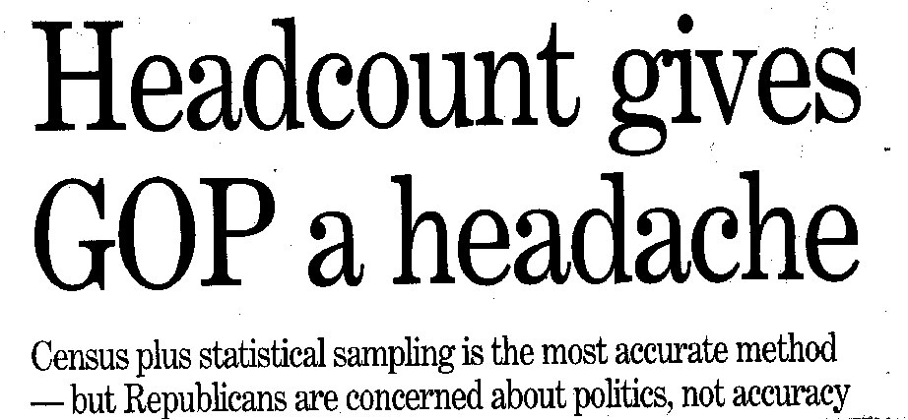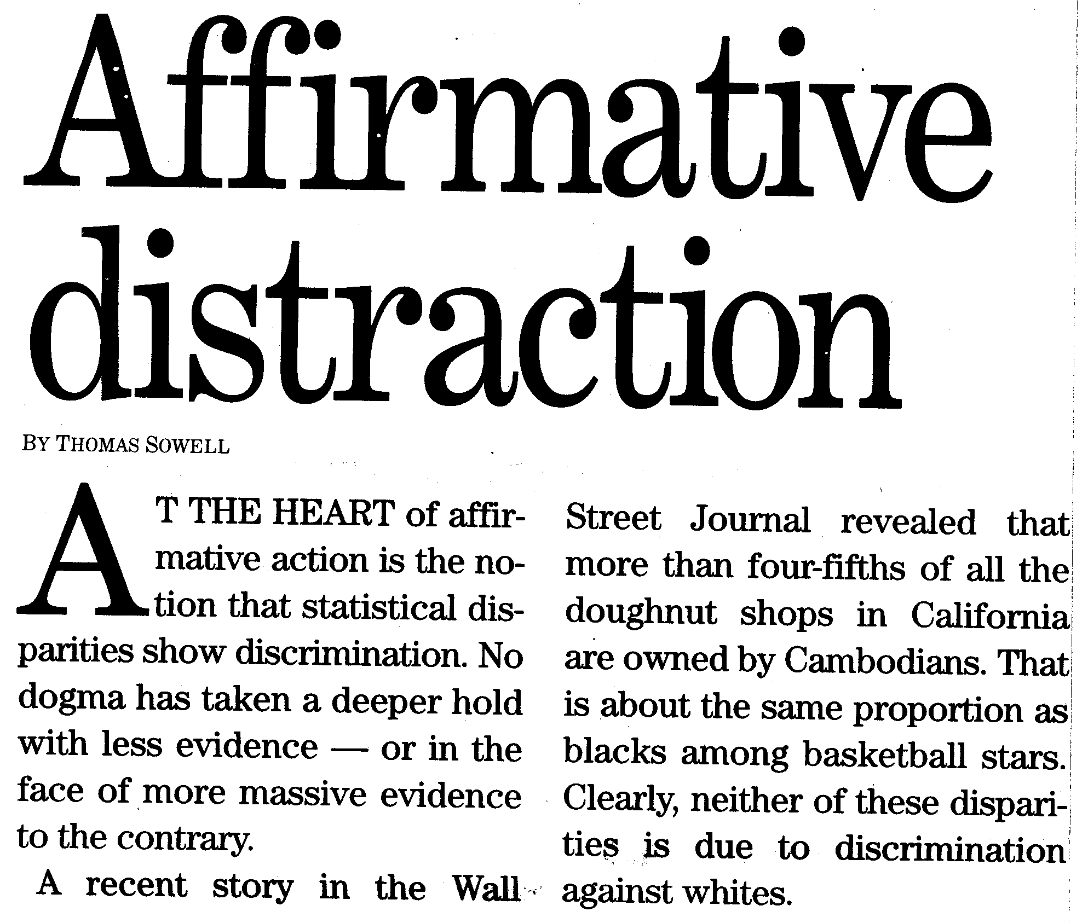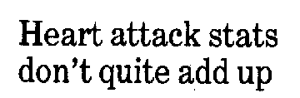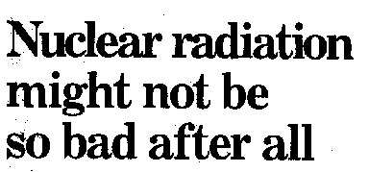
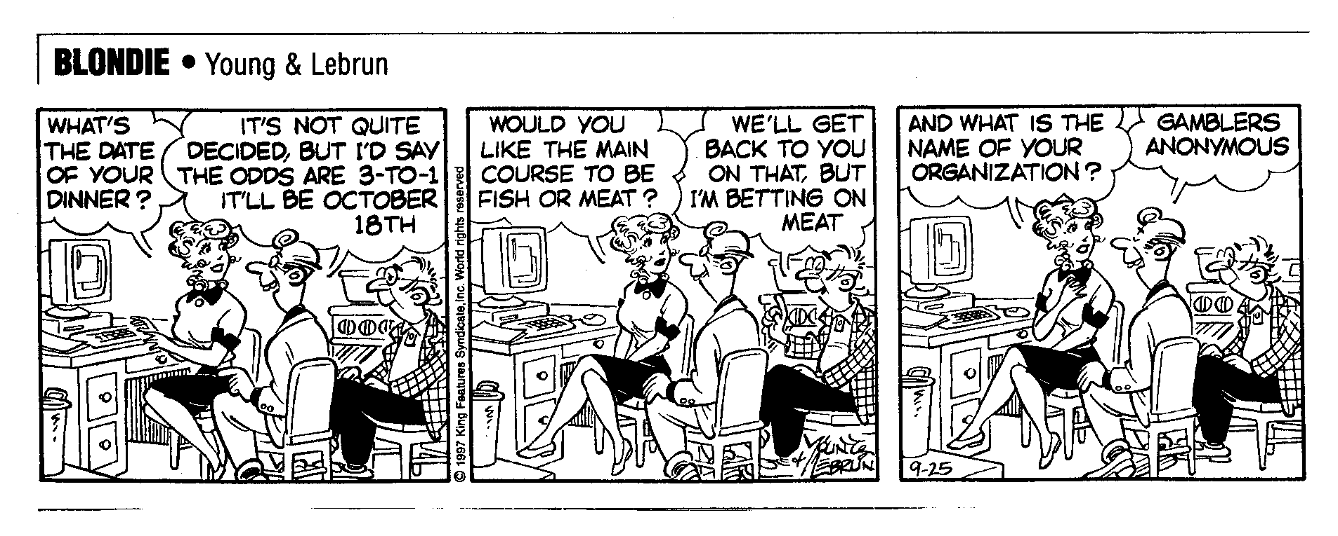
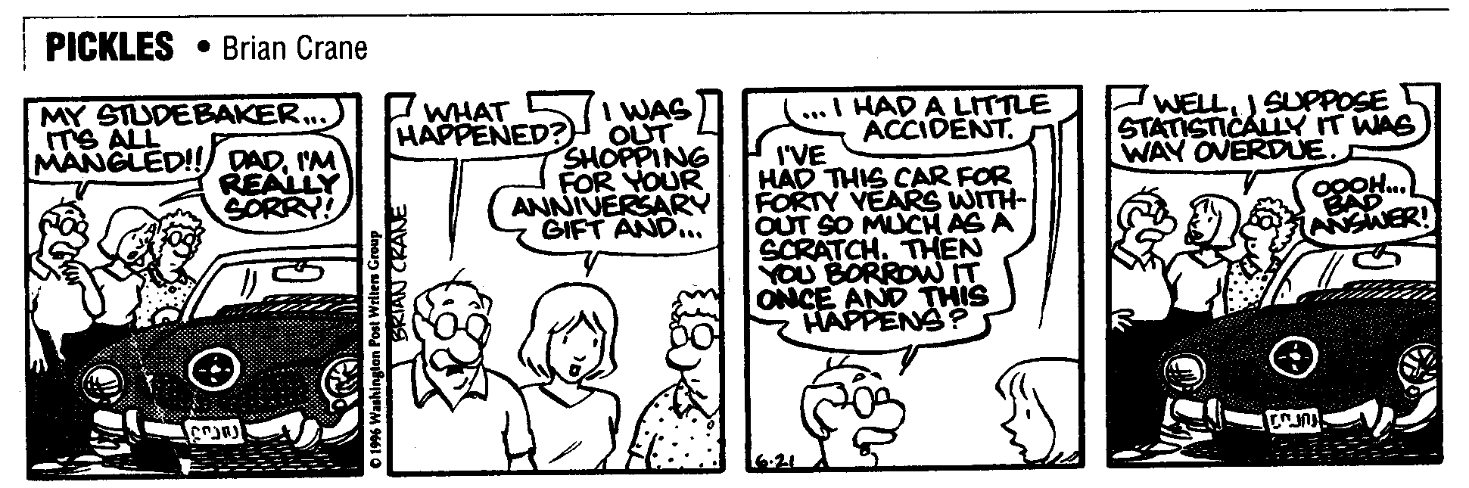

Introduction

As seen in the preceding headlines and cartoons, we grow up these days bombarded by the use of statistics and probability.

In spite of this, new students to the subject dread taking it:

Students have a “natural psychological reaction unfavorable to the study of statistics.”

(introductory statistics textbook, 1934)

"Statistics implies, for most students, a new way of thinking ⎯ thinking in terms of uncertainties or improbabilities....When confronted with statistics for the first time, some may find a mental hurdle which can be emotionally upsetting."

(introductory statistics textbook, 1960)

- The reasons for such reactions may lie buried in mankind’s own story of discovering the subject.

Philosophical Probability thru the End of the Renaissance

Probability and Chance in Ancient Greece

In ancient times, probability was a concept without any mathematical connotation.

In ancient Greece, even tho the equivalent of our word “chance” was used, it referred only to unexpected events caused by meddling deities.

Likewise, the word “probability” was used, but only to refer to an intuitively sensed degree of uncertainty about future events, events that could be predicted only by learning what the Gods planned to do next.

Socrates suggested that life’s unexpected events might not be due not to deities but rather due to other causes which are simply unknown to us. For this, he was condemned to death — his crime was that he “denied the reality of the gods and corrupted the youth of Athens.”

Plato wrote that arguments derived from probabilities are “impostors and ... apt to be deceptive.”

Aristotle wrote: “that which is probable is that which happens generally.” A modern historian has written that “Aristotle was the first to attempt an explanation of chance….[he stated that] chance is opposed to mind and reason and its cause cannot be determined.”

- An important comment (to be recalled later in this seminar) is that Hippocrates, the “Father of Medicine” and contemporary of Socrates, wrote that experimentation, in our sense of the word, was “futile” because the Gods controlled the outcome of any experiment. His approach to science was to collect what information existed, and to philosophize about it.

Medieval Rules of Evidence

The classical, theo-centric view of probability and chance and its anti-science stance was almost universally held until the Middle Ages.

One notable exception was Roger Bacon, who today is sometimes called the “Founder of Science”, but who in his day had little impact on the beliefs of society at large. Even tho he preached the value of experimentation, he did not depart significantly from the Aristotelian philosophical approach that still dominated all aspects of thought:
“… the Medieval [scientific] philosopher [including Roger Bacon] fitted the results on his experiments into a theory already firm in his mind [the theory having been obtained from Aristotle, the Church, or other authoritative sources]. He knew what “light” was before making experiments on refraction; he knew the cosmological significance of “weight” before attempting to determine the speeds at which heavy bodies fall.” (a modern historian)

At last, the first substantive change in philosophy came in the area of civil justice. In 1215, the Church outlawed torture in civil matters, torture sometimes being the way the courts asked for God’s input on the guilt or innocence of the accused (e.g., if the accused drowns when forcibly submerged, then he must have been guilty, otherwise God would have saved him). The alternative chosen was a system called the Roman-Canon Theory of Proof.

In that system, evidence was assigned a fractional numerical value. At the end of a criminal proceeding, the judge added up the numbers — he literally added up the evidence, as we still say today — and guilt or innocence was proven by the magnitude of the sum. This procedure was called the “arithmetic of proof.” In a sense, it was incipient mathematical probability, that is, the higher the number the greater the probability.

Later in the 13th century, the preeminent theologian Thomas Aquinas constructed a philosophical basis for the “arithmetic of proof.” He built his view upon probability’s classical definition: the Greek word for probability meant literally “resting on opinion” and the Latin equivalent meant “worthy of approbation.” Aquinas wrote that evidence was probably true if it were based on authoritative opinion — the more authoritative the source, the more probable its truth.

Mid-Renaissance Natural Philosophy

- Omens have always been both fascinating and terrifying, because they have been viewed as “signs” (i.e. messages) from God. An authoritative opinion about an omen would have a large numerical value in the “arithmetic of proof.”

- Similarly, tarot cards, tea leaves, and especially the outcome of a roll of 3 dice were considered controlled by God, and so therefore were signs from God, which could be interpreted if one knew how to read the signs (that is, read the tea leaves etc.)

- In the 1500’s, nature’s everyday appearance came to be recognized as much as “signs” from God as omens or tarot cards. This recognition was an outgrowth of a new philosophy called the Doctrine of Signatures that came to be accepted in a relatively short period of time as the norm in all walks of life, as the result of proselytizing by a well-known German physician named Paracelsus.

- The Doctrine of Signatures stated that Nature is the highest, most authoritative, most “probable” of all testimony. Accordingly, Nature is not just a work of God but his actual word, which is readily decipherable by those who know how to “read” the words, or rather “read the signs.”

The Doctrine of Signatures helped mankind begin to realize the relative importance of internal evidence such as shape, weight, and texture as compared to external evidence such as omens, books, and opinion.
Late-Renaissance Natural Philosophy

Francis Bacon was a lawyer who, in the early 1600’s, in the latter part of his life, became famous as a natural philosopher because of his publications on the experimental method, which came to be called the “Baconian Method.”

Prior to Bacon, almost all scholarly opinion agreed with Hippocrates’ ancient claim that experimentation is futile. As a result of which, except for the mechanical arts, “..in the early 17th century one knew for certain little more than Aristotle had known” (according to a modern historian).

No one had previously made experimentation a philosophical principle. “That men should deliberately experiment -- as distinct from merely observing nature [as stressed by the Doctrine of Signatures]-- had seldom been advocated, certainly not with the systematic thoroughness which Bacon proposed…. To Bacon, experiment was the one true necessary ingredient of scientific endeavor…the one true way.”

-- This philosophical principle was expressed clearly and forcibly in Francis Bacon’s writings in 1620, which were read by Blaise Pascal’s father. According to one of Blaise Pascal’s biographers, his father’s “enthusiasm had taken fire… [as a result of reading Bacon] [and he became] a fervent believer in experimental science. No Jesuits for him! No royal road to learning…a fig for the schools and their traditions! The training that he gave his children [he home-schooled his son, Blaise] was based upon physical notions [as well as religious ones]…” Based upon such philosophy, Blaise Pascal was soon to become the co-founder of mathematical probability.

Possibly his greatest contribution was as a proponent of inductive logic. “The method of induction was Bacon’s bid for a new logic to replace Aristotle’s [method of deduction]….” It is important to note that the approach taken to experimentation by Roger Bacon (the “Founder of Science”), 3 centuries earlier, was thoroughly Aristotelian.
“…to doubt Aristotle on one issue [such as that the earth revolves around the sun] was to doubt him on all, and consequently some problems of the scientific revolution…implied the annihilation of extant learning” and “the whole established body of natural philosophy”.
Gaming Odds before Mathematical Probability Was Understood

The Doctrine of Signatures and the Baconian Method produced in some Renaissance gamblers the belief that they or their mathematician friends could somehow objectively calculate gaming odds and thus gain an advantage over their less-experienced opponents. Aristotle’s implied claim that chance could not be calculated was about to be proven wrong.

The science of mathematical gaming odds might have developed earlier than the late Renaissance had not Christian theologians since at least the 4th century condemned gambling of all types. Justification for this ban was given by citing Old Testament passages in which God’s will had been sought by choosing lots ⎯ Christians were taught that to seek God’s viewpoint in this way was more than presumptuous, it was profane!

A few early publications included attempts to quantitate chance and/or provide a philosophy on which to base mathematical probability.

In 1525, Gerolamo Cardano wrote a 15 page manual on the rudimentary principles of gaming odds, entitled Book on Games of Chance.
- In the early 1600s, Galileo published his own short pamphlet entitled On Playing Dice, which explained most of the same ideas as had Cardano.
- In 1619, a Puritan minister named Thomas Gataker, in his Of the Nature and Use of Lots, echoing the writings of some renegade ancient Grecian and Roman philosophers, explicitly proposed that natural laws, rather than divine ones, determine who profits at games of chance.
- What is also amazing about these writings of Cardano, Galileo, and Gataker is that they appeared at a time when nearly everyone, except for a few professional gamers and mathematicians, still believed that God or a personified Fate controlled the outcome of gaming events. For example, the throw of three dice was still commonly used to foretell the future — a practice that was at that time over 2000 years old!

Mathematics & Statistics Thru The End Of The Renaissance

Mathematics in Ancient Times

- The earliest known textbook on mathematics dates from Greece 2400 years ago, at the time of Socrates

- After the Roman armies conquered the “world” two millennia ago, mathematical study among the peoples of the Empire went into decline. Supposedly, the obsessively practical ancient Romans were culturally disinclined from theoretical mathematics — no less an ancient Roman luminary than Cicero literally boasted that his countrymen valued mathematics only for counting and measuring.

- However, some Roman figured out the odds of life expectancy, to the extent that they were able to develop a reasonable chart of annuity cost based on age of the applicant. This information was lost when Rome fell, and not rediscovered for more than a millennium:
Many Renaissance municipalities and governments were funded in large part by the selling of fixed-rate lifetime annuities — that is, and old and young buyers paid the same price for a lifetime of the same annual payout. Only in the late 1600s (after the discovery of the principles of mathematical probability and Statistical science) did some governments begin to put their annuity prices in line with mathematical probability and actuary data,. But the English government waited another 100 years to abandon fixed-rates, for fear of interfering with one of its primary means of financing wars: “no British government before 1789 appears to have made the cost of an annuity a function of the age of the purchaser”

- An Indian poet who lived in the early Christian era, seems to have been the first person in the world to discover the principles of Statistical science. The principles are included in the Story of Nala, in the great epic poem Mahabarata. The story contains explanations and examples of sampling and gaming odds; however, it appears that nobody but the author understood that this was not science fiction, for no further discussion can be found in any extant Indian texts.
Mathematics and Pre-Renaissance Church Teachings

- In the early Christian era, St. Augustine emphatically proclaimed that “the good Christian should beware of mathematicians [because they] have made a covenant with the devil to darken the spirit and to confine man in the bonds of Hell.” What he meant was that mathematicians were invariably astrologers.
- The Roman Code of Mathematics and Evil Deeds condemned the art of mathematics because of its astrological connection.
- In the early medieval era, the word “mathematics” actually meant astrology, and teachers of astrology were called mathematicii. Universities, all of which were run by the Church, took a theologically conservative stance by teaching only arithmetic and geometry.
- “In no one of the civilizations that have contributed to our modern one did mathematical learning exist on as low a level as it did in medieval Europe. All in all, a learned European mathematician of a thousand years ago knew far less than any elementary-school graduate does today....From the years 500 to 1400 there was no mathematician of note in the whole Christian world.” (Noted mid-20th century mathematics historian)
- In the late medieval era, after algebra was introduced and was deemed to greatly improve on astrological calculations, the words physician and “algebraist” came to be almost synonymous.

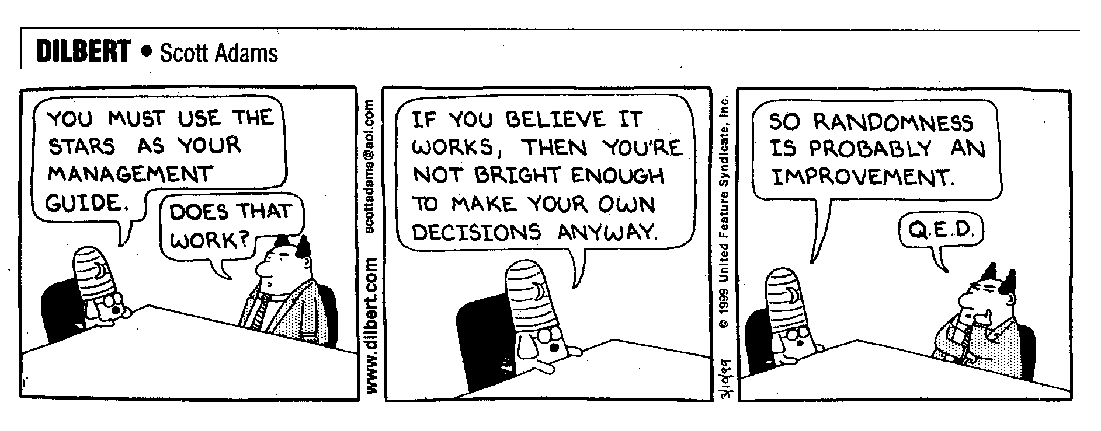
Mathematics during the Renaissance

- Laws were passed that mandated the exclusive use of Roman numerals, and forbade the used of “Arabic” numerals, in commercial contracts and official documents (e.g. in Florence as late as the year 1299). Although Arabic numerals gradually became accepted in Italy in the early Renaissance, it wasn’t until the late 1500s that they became the commercial standard in all of Europe.

- "The long and strenuous work of the most gifted minds was necessary to provide us with simple and expressive notation which...enables even the less gifted of us to reproduce the theorems which [previously] needed the greatest genius to discover....Our notation is an instance of the great spirit of economy which spares waste of labour"

- “The very concept of averaging is a new one, and before 1650 most people could not observe an average because they did not take averages. Certainly a gambler could notice that one strategy is, in Galileo’s words, ‘more advantageous’ than another; but there is a gap between this and the quantitative knowledge of mathematical expectation.”

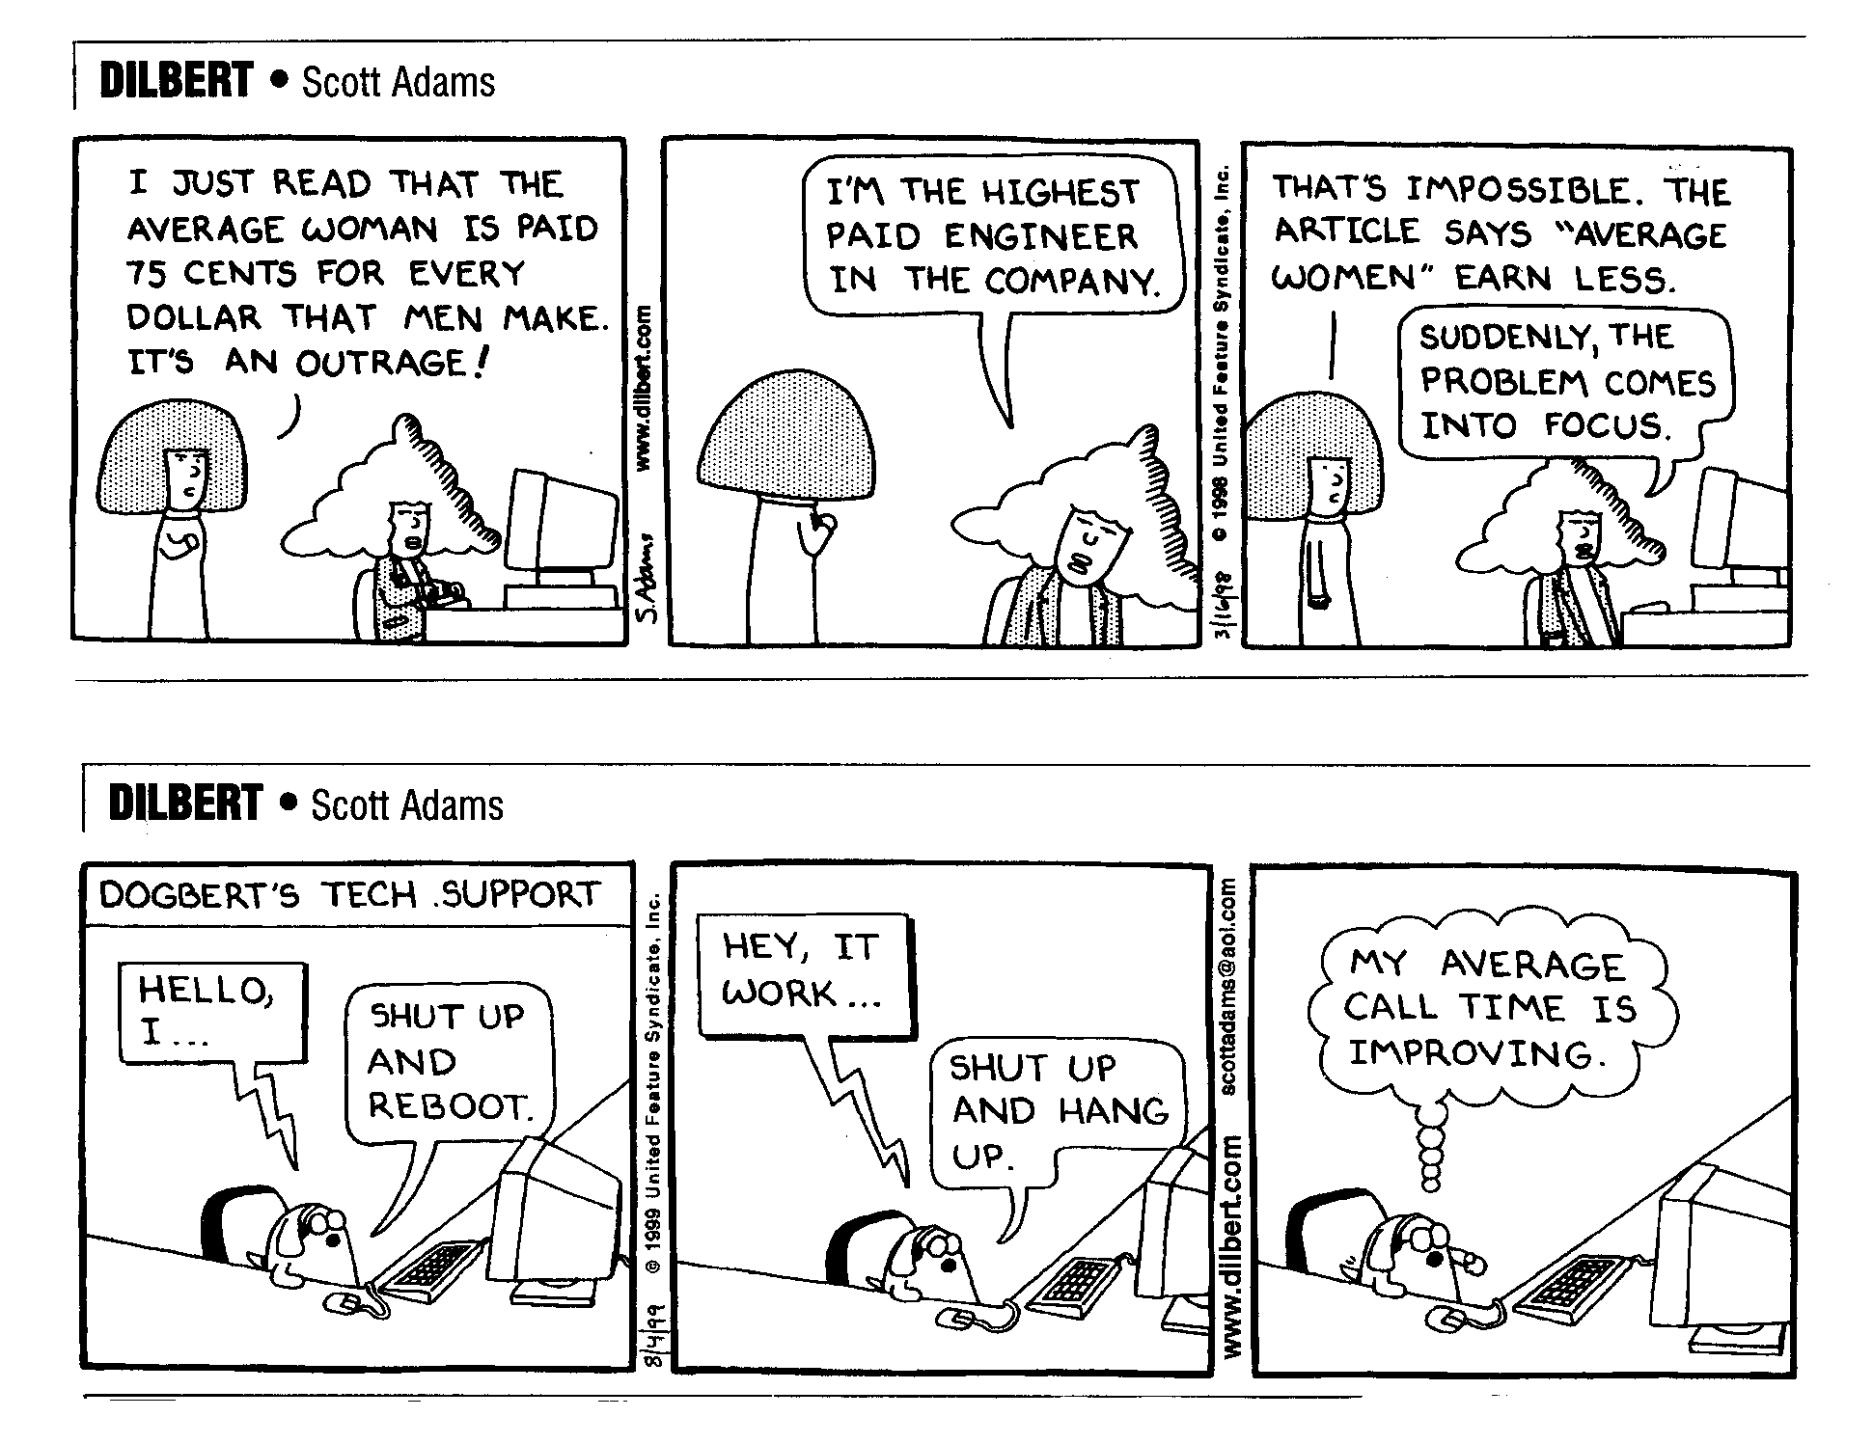
The Birth of Mathematical Probability & Statistical Science

The Birth of Mathematical Probability

- “By 1630, two generations of effort [to advance knowledge beyond that of the ancients] had hardly seemed to be rewarded, and science appeared as much unorganised as ever. Yet…all reached fruition in the next thirty years.” (noted 20th-century historian of the scientific Renaissance)

- In late 1654, Blaise Pascal, a celebrated mathematician and inventor, became enthralled with solving a gambling problem that had stumped mathematicians for over 150 years. By mail, he consulted other mathematicians, including Pierre de Fermat, a lawyer and part-time mathematician. The letters that these two sent to each other in the next few months, discussing how to solve the problem, are generally considered to comprise the first real theory of mathematical probability.

- During the late-Renaissance, the word “probable” was generally reserved for assertions that were "not completely ...impossible" or had "an appearance of truth" or were "midway between truth and error." By the mid-1700s, after decades of mathematical treatment of probability by mathematicians and gamblers who followed in the footsteps of Pascal and Fermat, use of the word “probable” among the general public shifted to the somewhat mathematical concept expressed by Kant as "more than half certain."
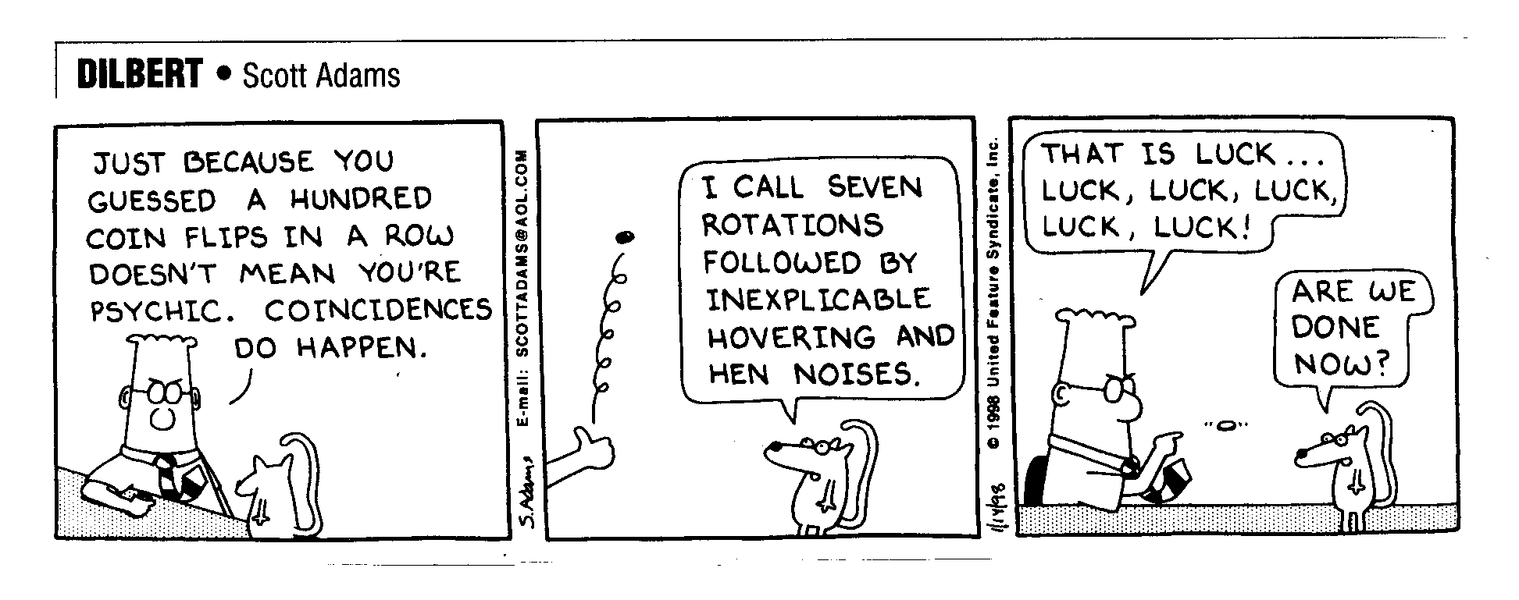
The Birth of Statistical Science

- The science of Statistics was born as the result of a hobby indulged in by John Graunt, a prosperous London shopkeeper and amateur collector of numerical data. In 1662, apparently not yet aware of Pascal and Fermat’s achievement, he published his Natural and Political Observations Made Upon the Bills of Mortality. It contained practical applications of his independent discovery of the basic concepts of statistical methods and sampling.

- His book was the first published account in the Western world where inductive logic and a sample of data were used for what we call statistical inferences.

- The first such statistical inference in Western history was Graunt’s calculation of London’s population size.

- Another famous Graunt inference was that slightly more males babies were born than females, year in, year out, in all socio-economic and ethnic categories.

- The first abuse of statistics: What did this male/female ratio mean?

- Statistical Science was known 300 years ago as “Political Arithmetic,” because the information it generated was primarily used for decisions by the body politic, i.e., the State; such information about the State came to be called “Statistics” (from root German words that mean “relating to the State”). The term Statistics completely supplanted the term Political Arithmetic in the 1800s.

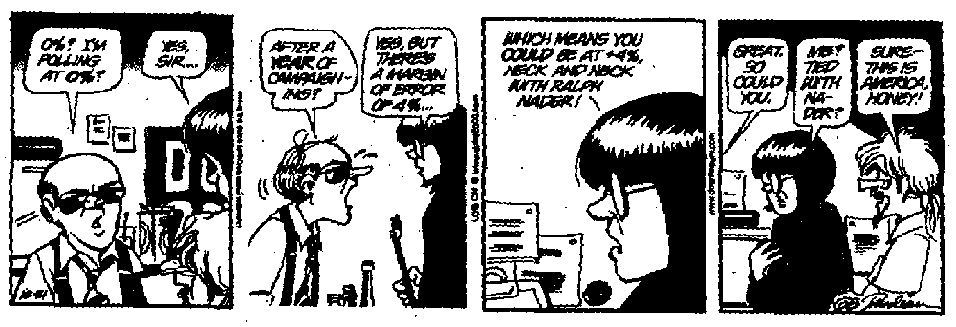
Why Was/Is It So Difficult to Discover/Learn/Understand Statistics & Probability?

- No one really knows (1975, by a well known historian of statistics and probability)

- “The mind all too readily tends to mould facts into the forms of prior conceptions” (1896, from a textbook on “inductive logic”); and many of our prior conceptions run contrary to a view of the world consistent with mathematical probability and statistical science.

- For example, as a society, we still think much like people did millenia ago:
- “To say an event is determined by chance is to say we do not know how it is determined” (1940, from a book designed to “popularize” mathematics).
- When an unexplainable event occurs (such as the remission of a serious illness), many of us say that a miracle has occurred. After the bonfire tragedy at Texas A&M University in 1999, which followed on the heals of a tragic car accident on campus, one student was quoted in the national press as saying that “I guess we’re just having a string of bad luck.”
- If the local baseball team hasn’t won in long time, we say “they’re due.”
- Almost all of us believe that it’s much less likely for the numbers 1, 2, 3, 4, 5, and 6 to be drawn in the lottery than other combinations.
- We still believe that certain people are lucky (“She always wins when she goes to Reno”), or that we ourselves are “just not lucky.”

In Conclusion:

Probability and Statistical Science are new ways of thinking about our physical world. Some paradigms held by our culture predispose us to have great difficulty, or an impossibility, in comprehending this view.

- This subject will always be difficult for those with a fatalistic view of life.
- This subject will always be difficult for those to whom formal authority (or a con-man) takes precedence over their own logic and observations.
- A Statistic’s teacher’s challenge is more about teaching new attitudes, philosophy, and independent thought processes than about teaching math.

